**DAILY ONLINE ACTIVITIES SUMMARY**

|  |  |  |  |  |  |  |  |  |
| --- | --- | --- | --- | --- | --- | --- | --- | --- |
| **Date:** | **12/06/2020** | | | | | **Name:** | **V ANJANA PAI** | |
| **Sem & Sec** | **IV sem & B section** | | | | | **USN:** | **4AL18CS094** | |
| **Online Test Summary** | | | | | | | | |
| **Subject** | | **AADALITHA KANNADA** | | | | | | |
| **Max. Marks** | | **25** | | **Score** | | | **23** | |
| **Certification Course Summary** | | | | | | | | |
| **Course** | **Java Programming** | | | | | | | |
| **Certificate Provider** | | | **Greatlearning academy** | | **Duration** | | | **3.5 hours** |
| **Coding Challenges** | | | | | | | | |
| **Problem Statement**: Given two positive integers start and end. The task is to write a Python Program to print all Prime numbers in an interval. | | | | | | | | |
| **Status: Executed** | | | | | | | | |
| **Uploaded the report in Github** | | | | | **YES** | | | |
| **If yes Repository name** | | | | | **lockdown-coding** | | | |
| **Uploaded the report in slack** | | | | | **YES** | | | |

Online Test Summary: 18KAK49 test was scheduled from 11:35am to 12pm.The portion for IA was all 10 chapters there was 25 questions and time assigned was 25 min. The questions were MCQ type.

Online Certification Course Summary: In today’s session I learnt about Inheritance in Java and also about the Collections in Java and successfully completed the Java Programming course by taking up the Quiz and obtained the completion certificate.

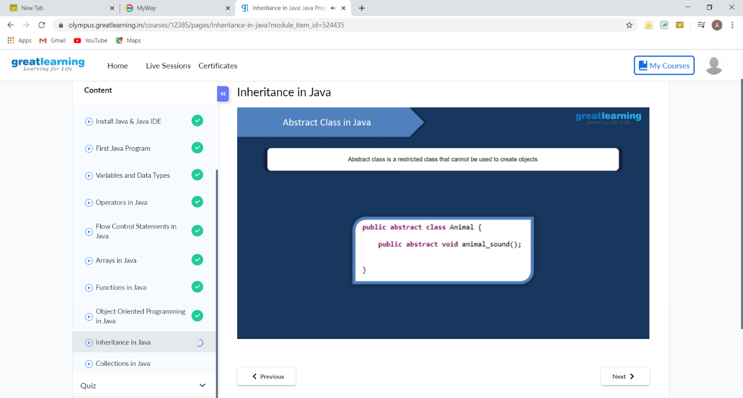

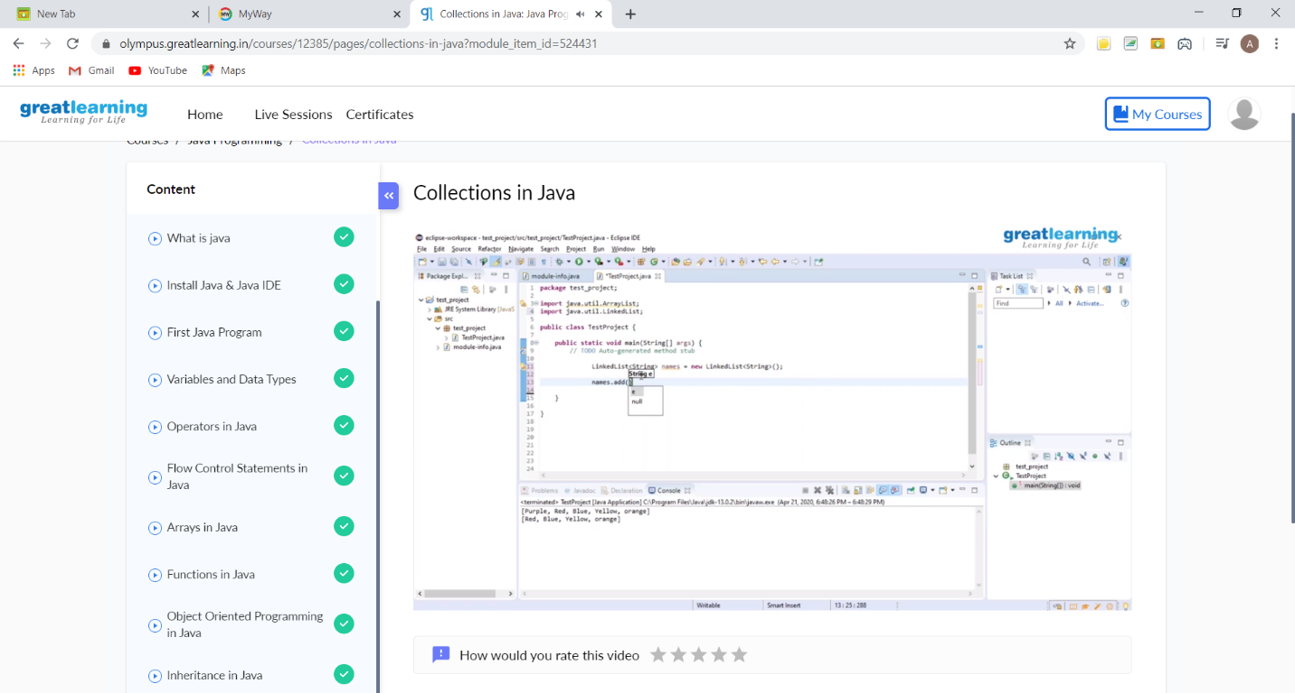

These are the snap shot of today’s session.

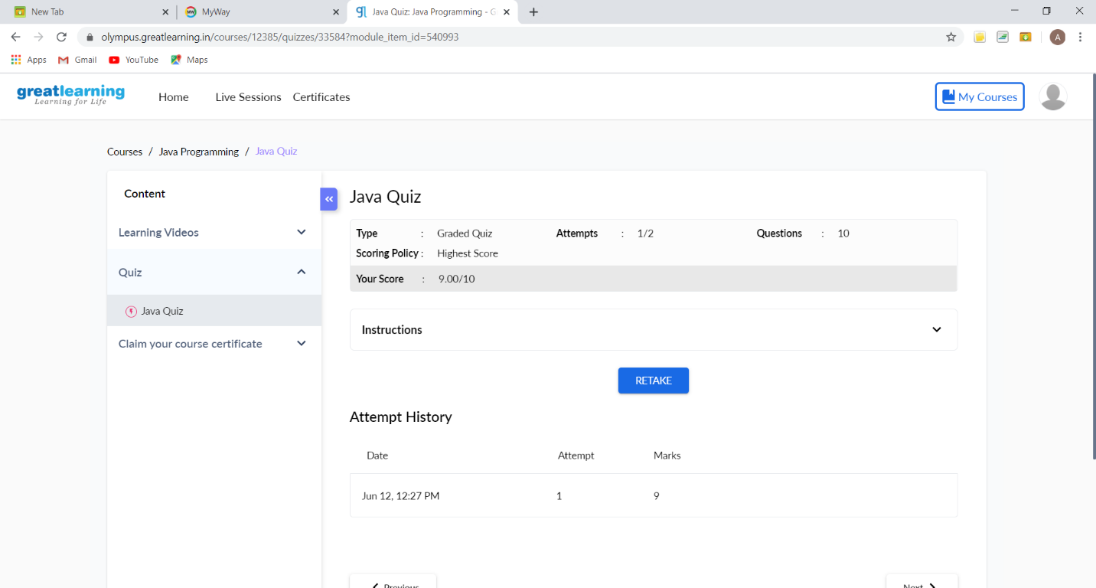

This is the snapshot of Quiz taken.

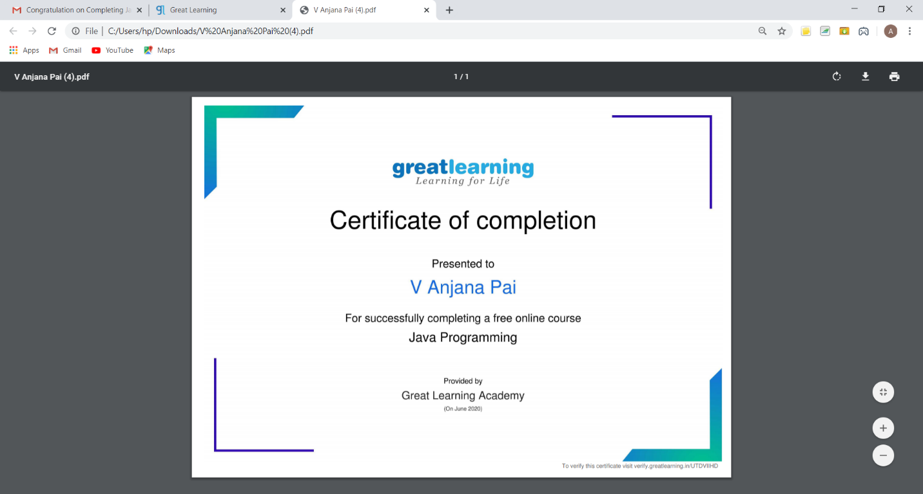

This is the snapshot of the certificate obtained.

Online Coding Summary: **Today I had received one program from prof. Vasudev CSE Dept. The program is mentioned above in the coding challenges(pg.01). I have also uploaded it to my Github repository.**

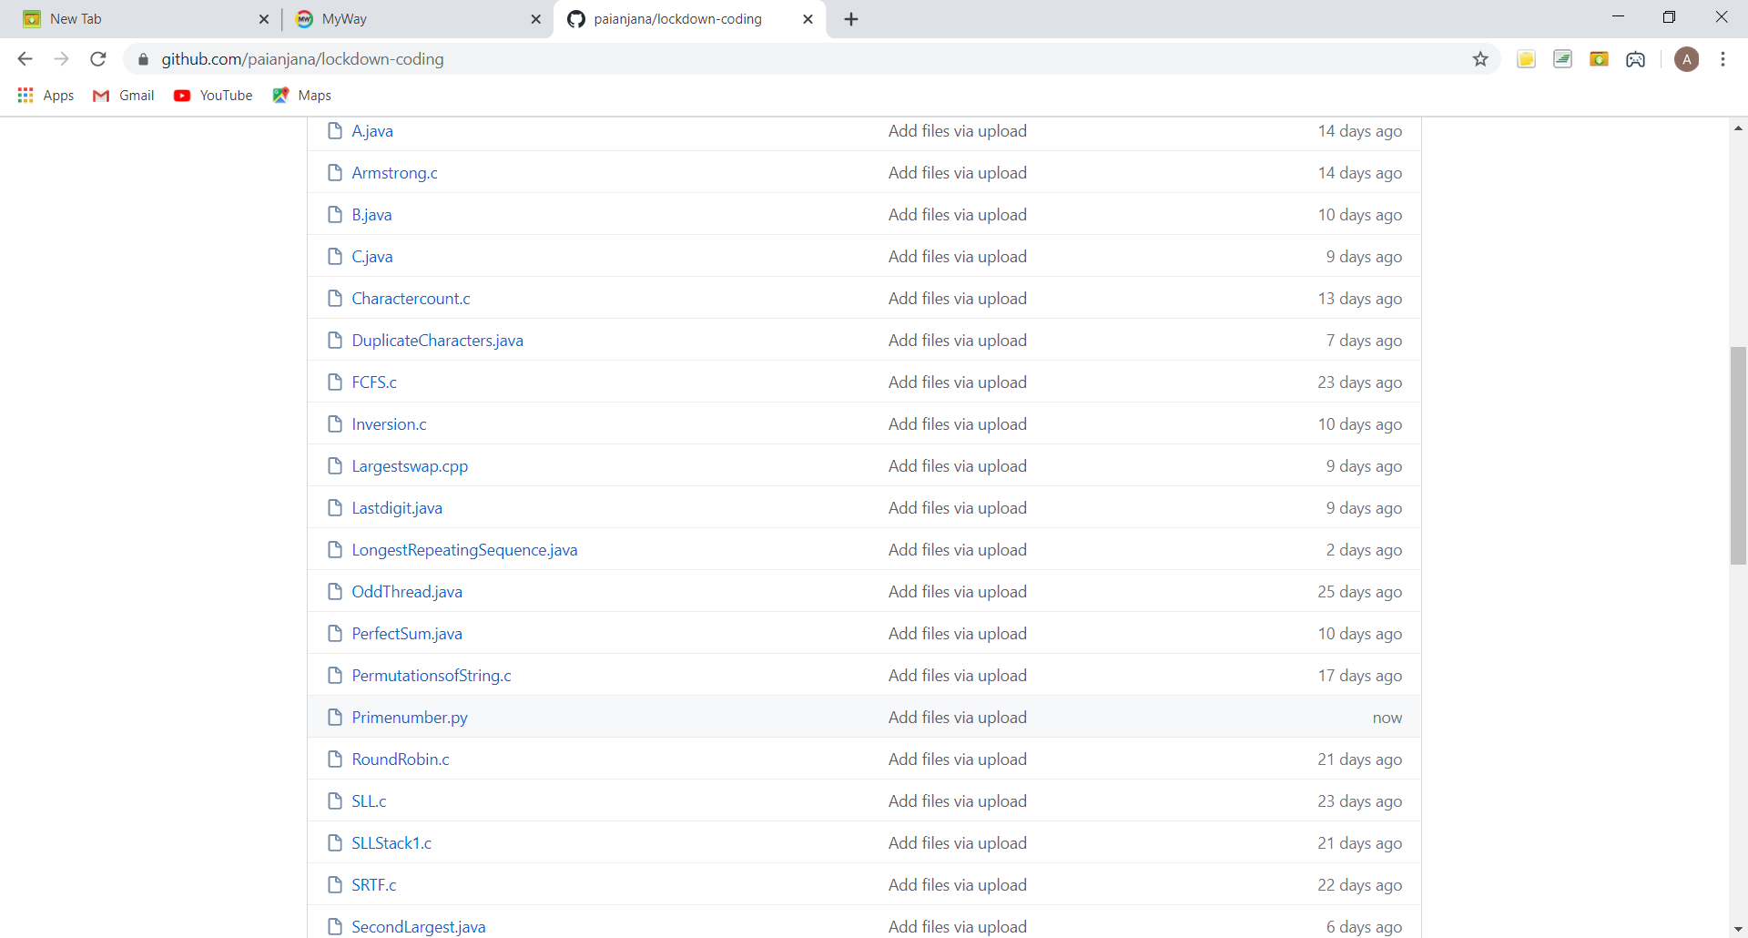

It is the snap shot of my repository where I have uploaded the code. File name is Primenumber.py